Nicholas Skinner

CS321

Fall 2019

Homework 6

1. **Show that the family of context-free languages is closed under reversal.**
   1. Let G be the context-free grammar that generates the language L.
   2. We will construct a new grammar from G.
   3. G0 is as follows.
   4. For every production X -> v of G, we add the production X -> vR in G0 , where X is a variable, and v is a string of terminals and variables.
   5. We can see that that string w is generated by grammar G if and only if the string wR is generated by grammar G0 .
   6. Therefore, grammar G0 generates the language LR , and thus the language LR is context-free
2. **Show that the family of context-free languages is not closed under difference.**
   1. 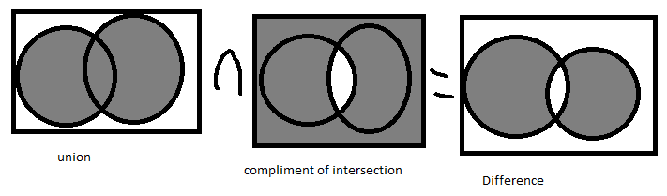
   2. (A∪B)∩($\underline{A∩B}$)
   3. This makes the difference between A and B, which due to intersection and complement is not regular.
3. **L1 = {a^n b^m : n = 2^m}.**
   1. Case 1: pump A
      1. a^(2^(m)) b^(m)
      2. k>=1
      3. a^(2^(m+1)) b^(m) is not contained in L
   2. Case 2: pump B
      1. a^(2^(m)) b^(m)
      2. k>=1
      3. a^(2^(m)) b^(m+k) is not contained in L
   3. Case 3: pump either v or Y containing A or B
      1. W2 = the A’s and B’s are out of order, this does not follow our sequence
   4. Case 4: pump A and B
      1. a^(2^(m)) b^(m)
      2. l>=1
      3. k>=1
      4. pumped string will look like
      5. a^(2^(m) +(i-1)k) b^(m +(i-1)l)
      6. 2^(m-k) = 2^(m) - l
      7. 2^(m+k) = 2^(m) + l
      8. Multiply it out
      9. 2^(m-k) 2^(m+k) = (2^(m) - l )(2^(m) + l)
      10. 2^(2m)=2^(2m)-l^(2)
      11. Since k = 0 and l=0, this implies |vy| = 0, so we have a contradiction
4. **L2 = { a^n b^n c^j : n ≤ j }.**
   1. Case 1: pump A
      1. k>=1
      2. a^(m + k) b^(m) c^(m+2) is not contained in L
   2. Case 2: pump B
      1. k>=1
      2. a^(m) b^(m +k) c^(m+2) is not contained in L
   3. Case 3: pump C
      1. k>=1
      2. a^(m) b^(m) c^(m+2 - k) is not contained in L
   4. Case 4: pump A and B
      1. k1>=1
      2. k2>=1
      3. a^(m + k1 ) b^(m + k2) c^(m+2) is not contained in L
   5. Case 5: pump B and C
      1. k1>=1
      2. k2>=1
      3. a^(m) b^(m+k1) c^(m+2 + k2) is not contained in L
   6. Case 6: pump A and b in v/y
      1. W2 = the A’s and B’s are out of order, this does not follow our sequence
   7. Case 7: pump b and c in v/y
      1. W2 = the A’s and B’s are out of order, this does not follow our sequence
5. **L3 = { w: w {a,b,c}* and na(w) < nb(w) < nc(w) }**
   1. Case 1: pump A
      1. k>=1
      2. a^(m + k) b^(m+1) c^(m+2) is not contained in L
   2. Case 2: pump B
      1. k>=1
      2. a^(m) b^(m+1+k) c^(m+2) is not contained in L
   3. Case 3: pump C
      1. k>=1
      2. a^(m) b^(m+1) c^(m+2-k) is not contained in L
   4. Case 4: pump A and B
      1. k>=1
      2. a^(m + k1) b^(m+1+k2) c^(m+2) is not contained in L
   5. Case 5: pump B and C
      1. k>=1
      2. a^(m) b^(m+1+k1) c^(m+2+k2) is not contained in L